Experiment – Using a Bunsen

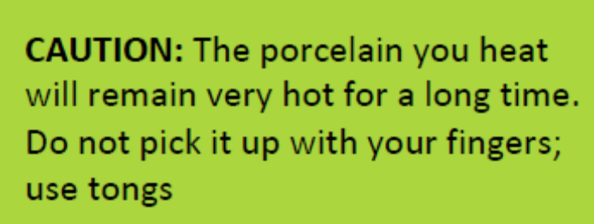
What you need
- Bunsen Burner
- Heat proof mat
- Matches
- Tongs
- 2 pieces of white ceramic / porcelain
Steps:
Wear Safety glasses, hair tied back, enclosed shoes and BE SENSIBLE
- Follow steps to light a Bunsen burner (only if you got the Bunsen Badge)
- Change the flame to the blue flame by opening the air holes on the collar
- Write down and draw what happens to the flame when the hole is closed, half open and full open.
- Close the collar so a yellow flame is produced
- Using the tongs, hold a piece of porcelain in the top of the yellow flame for a minute. Place it on the heating mat when you finished. Describe what happens to the Porcelain and draw it.
- Hold the other piece of porcelain with the tongs. Change the flame to blue and heat the porcelain for a minute. Describe what happens to this porcelain and draw it.
Results:
- Describe and draw what happens when …
Holes are closed | Holes are half open | Holes are fully open
Description: | Description: | Description:
Drawing | Drawing | Drawing

- Describe and draw the porcelain when…
Heating with yellow flame for a minute | Heating with the blue flame for a minute
Description: | Description:
Drawing | Drawing

QUESTIONS
- Why do you think the yellow flame is called the safety flame? Give at least two reasons

- Which flame is noisier: blue or yellow? Why is this helpful to know?

- Which flame leaves a sooty carbon black deposit?
- Which flame is the ‘clean’ flame for heating?
- Give reasons for using a blue flame for heating in an experiment?

